DAANY BEÉDXE

THE JAGUAR SACRED MOUNTAIN.

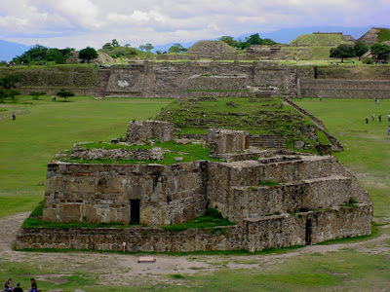

Visiting Monte Alban is opening a door to the incommensurable and wonderful of our oldest cultural legacy. It is going to the depths of our being.

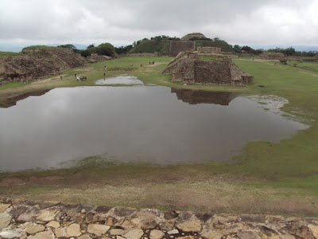

Indeed, Monte Alban known as "the Jaguar sacred mountain" or as the ancient Toltec grandparents called it in Nahuatl; Tehuantepec.

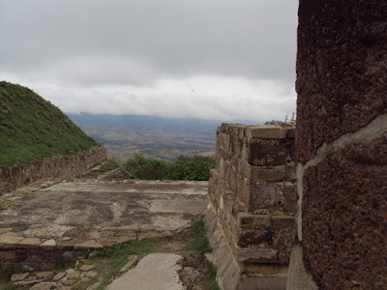

And known in the Zapotec language as "Danibaa" which means, "The sacred mountain" or Daany Beédxe as "The Jaguar mountain", it is without a doubt one of the major construction projects of the Cem Anahuac, also due to its size, the oldest and most important.

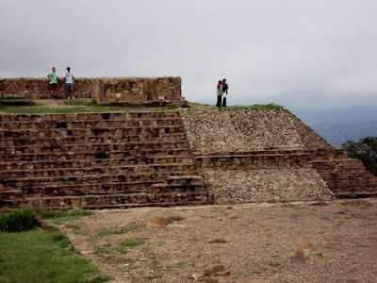

"The Jaguar sacred mountain" began its construction approximately in the year 500 BC, with the participation of all the peoples that we now call Oaxacan.

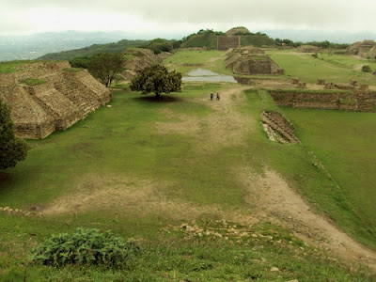

Logically, the population density of the central valleys during the 5th century BC was very small. The monumental work under permanent construction lasted 1350 years.

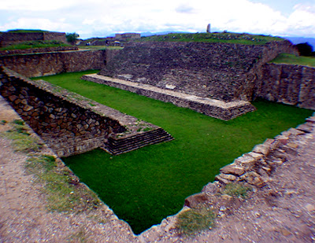

For performing this titanic effort it required coincidence of several strategic factors of paramount importance. Firstly an irrefutable objective and that it did not expire.

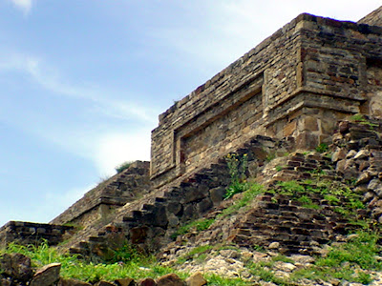

That it was valid for all human beings, peoples and cultures for over thirteen centuries, for which they were willing to work from generation to generation.

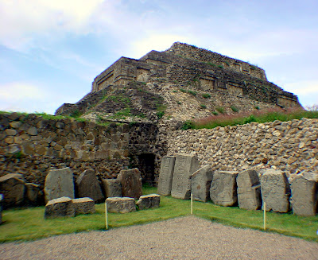

It required an appropriate food system that provided enough energy for the enormous effort and the time to do it.

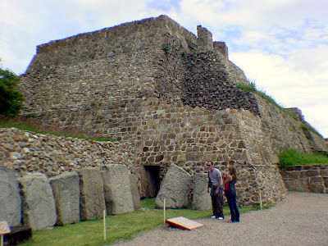

Since a period of the year was devoted to the body sustenance and another period to nourishing the spirit. Our ancient grandparents lived in "balance" and moderation.

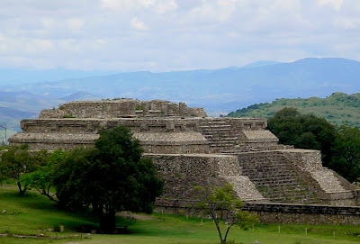

It also required, an effective health system that allowed through habits, practices and sophisticated expertise, maintaining a hygienic life and permanent health to undertake the constructive challenge and the body natural organic wear.

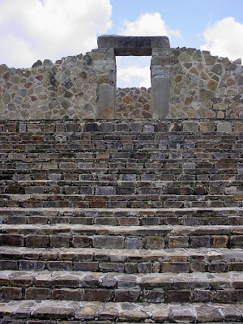

In addition required, possessing an efficient education system that would remain firm and clear through centuries, the original constructive purpose in society from generation to generation and that only can be done through education.

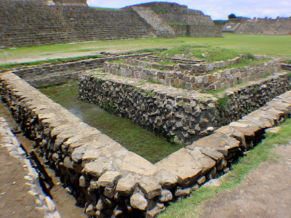

It required having an effective social organization system that would enable all peoples and cultures, to divide the work and organize it for more than thirteen centuries, the monumental feat among all the peoples and cultures of what today is Oaxaca.

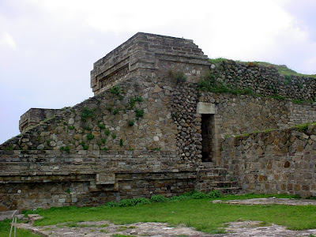

"The Jaguar sacred mountain" belongs to all the Oaxacans of yesterday and today. It was built as has been built and still constructs the large "common well" works, through solidarity, community work and community organization.

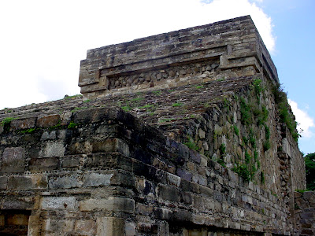

It couldn't have been otherwise, as today no "common good" works can be built, without community participation. Monte Alban has been and continues to be Cultural and spiritual Heritage of all Oaxacans.

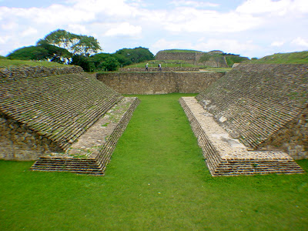

Monte Alban could not have been product of the messianic dream of a handful of delusional and exalted. Instead, it was product of the spiritual potential, the will of power, the ancient wisdom and the social organization of an ancient civilization that sustained their human development in the power of the spirit.

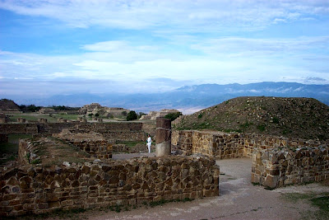

Only foreign archaeologists and their Mexican assistants, dare to think that "The Jaguar sacred mountain" was the work of an imperial project supported in material power and limited vision of the ephemeral temporal world. They fail to have the "sensitivity" to perceive their spiritual greatness.

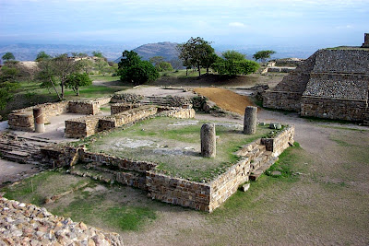

And finally it required, having a superlative goal that was reliable and perennial in terms of the use and exploitation of the imposing work for all peoples. That is, that it "worked" for what was conceived.

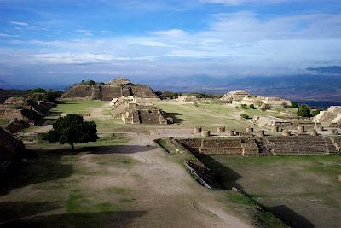

What was the reason for which they built this monumental work over thirteen centuries and that since its first phase, in the fifth century BC, until its abandonment remained unchanged?

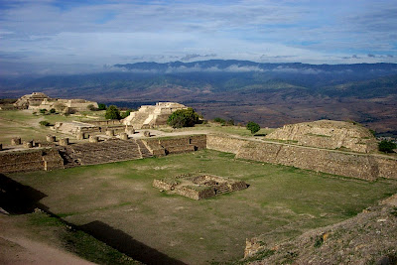

Indeed, "the Jaguar sacred mountain" must have fully met its objectives, reason why the constructive effort was maintained. The architectural plant of phase I is the same as the phase of its abandonment, a thousand three hundred fifty years later.

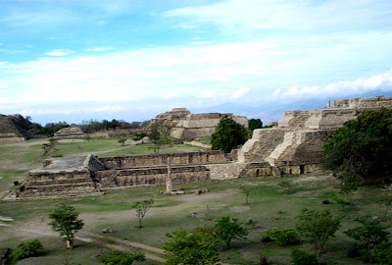

This is important because it reveals that, "for what it was designed from the beginning, it worked properly until its abandonment. This is one of the great mysteries of the Anahuac and precisely therein lies their human greatness.

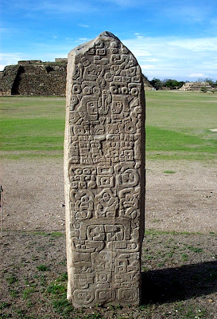

"The Jaguar sacred mountain" not was a city, because a water source never existed around and without the vital liquid; no human group can live and much less develop a project of these dimensions and duration.

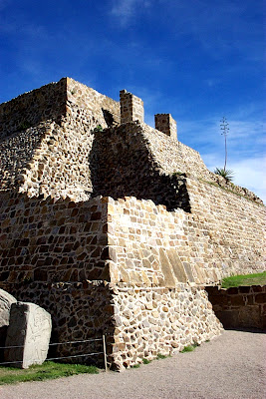

Because its architecture is not that of a "dwelling". They could not carry up billions of tons of stone to make a "Palace" in rooms that have a door the size of a wall, which is illogical and unacceptable.

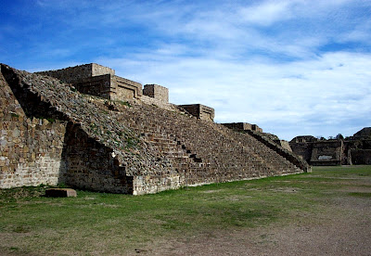

Because urban centers around the world have always been constructed in places near a permanent water source and preferably flat spaces, and residences are proportional to human needs. In Monte Alban this condition does not exist.

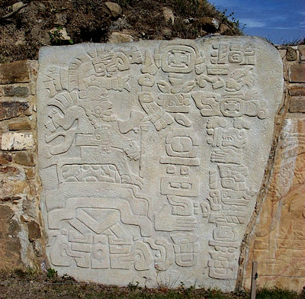

"The Jaguar sacred mountain" was not a fortress, because besides not having defensive architecture (walls, trenches and towers), there were no wars in the classical period.

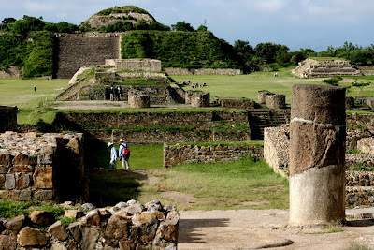

"The Jaguar sacred mountain" was not commercial center, because it is illogical to carry goods "up and down" (without load animals and wheel), having the valleys for this purpose. In addition it must be considered that there was no currency or private property in the Cem Anahuac in the classical period.

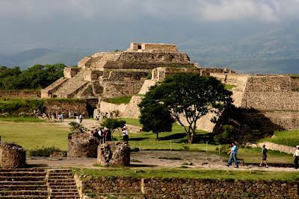

"The Jaguar sacred mountain" was not a hospital, because it is illogical to make such a large effort and for such long time to construct atop four hills a service of this type, and to date, in the Cem Anáhuac a construction with this objective is not known.

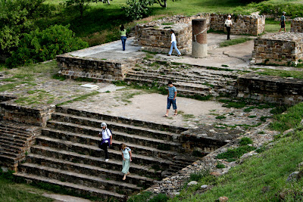

What was then this incommensurable effort constructed for, which took so many generations who worked through the centuries and that never changed its purpose. What was the sacred idea that conceived it.

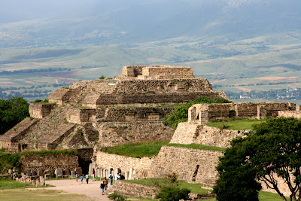

What was then this incommensurable effort constructed for, which took so many generations who worked through the centuries and that never changed its purpose. What was the sacred idea that conceived it.

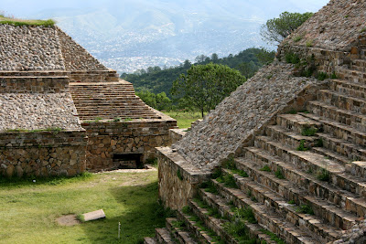

What should have moved hundreds of thousands of people through more than thirteen centuries to give their "tequio" and come from all over of what today is the State of Oaxaca, to work on a project shared in time and space by all the anahuacas peoples?

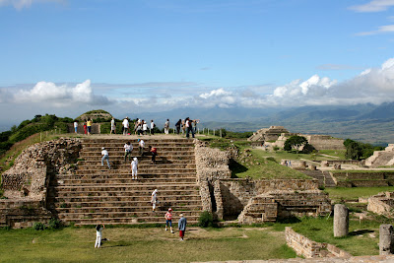

What was that "immutable truth" that all shared and strove for it? That "transcendental truth" that never expired and did not go out of fashion and that inspired so many generations and so many different people.

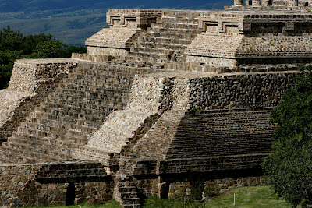

When the peoples of Mexico in general and the Oaxacan in particular can answer this question, surely everyone's life will completely change. The legacy of our ancient Toltec grandparents will once again be ours.

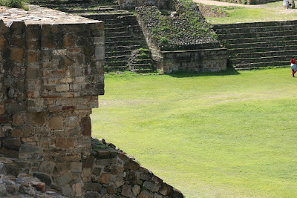

When we find the answer inside our hearts, in the brightest of our spirit, our true essence.

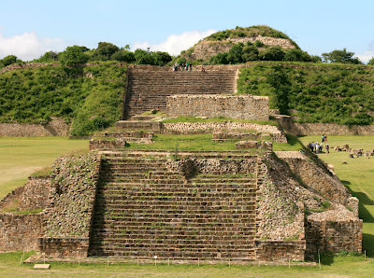

When we return to the warrior path. When again we engage the Florid Battle in the depths of our hearts. When we come back to be warriors of the flowered death. When our hearts bloom again.

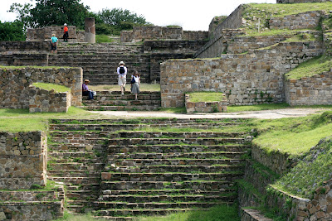

When we manage to do "archaeology of the spirit" in our consciences. When we re-learn to see us in the "smoking mirror" and recognize our true face and our true heart will again flourish the sacred mountain.

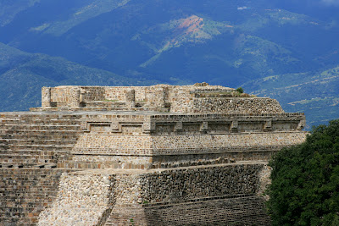

When we manage to stop mental and cultural colonization. When we break the ignorance chains of ourselves, generated by the colonizer.
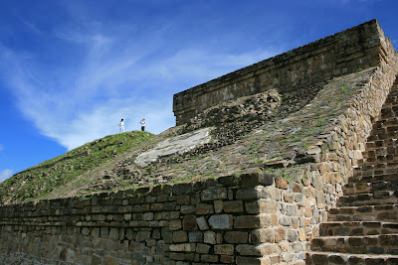

When we learn clearly and well defined who we are, where we came from and where are we going. When we recognize ourselves in the millennial thoughts of our wise ancestors, as the people of China or India proudly do today.

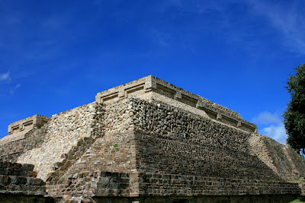

When we learn clearly and well defined who we are, where we came from and where are we going. When we recognize ourselves in the millennial thoughts of our wise ancestors, as the people of China or India proudly do today.
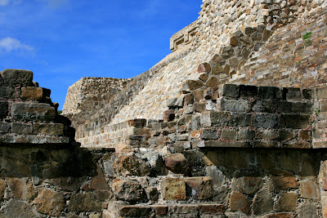

When we stop being "uneducated foreigners in our own land". When we stop trying to be third class spaniards, French or American and fully become first class anahuacas.

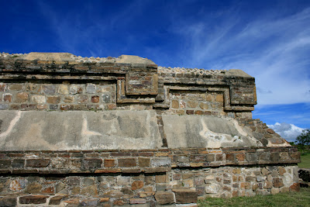

When we "activate the gene bank of cultural information" that exists in each one of the sons of the sons of the ancient grandparents.
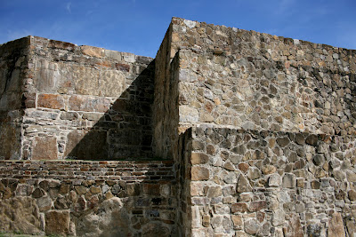

"The Jaguar sacred mountain" will again wake up, and will be a guide for each of us, our families, our people and our country.

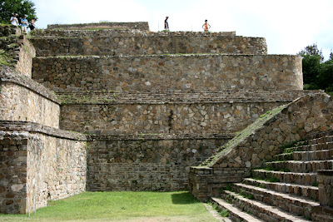

We shall recover the "historical memory" and thereby recover our identity, our dignity and our mission as human beings and as a civilization.

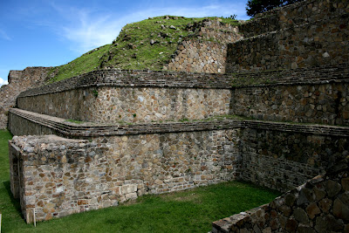

The discovery of "the Jaguar sacred mountain" in the bottom of our heart will be the beginning of the end of the colonization and the dawn of the new cycle of our destination, destination shared with all the ancient peoples of the world.

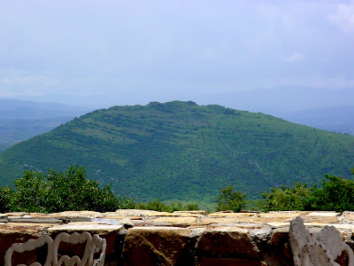

"The Jaguar sacred mountain" represents the best of our future; therefore it is true that our future lies in the knowledge of our glorious past.
glconrado@hotmail.com

